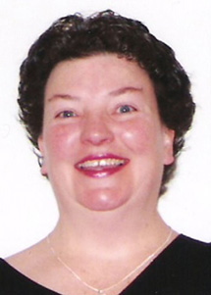  Peggy Dolan,  Ohio County Schools  French, Spanish teacher; NBCT  pegdolan@gmail.com | 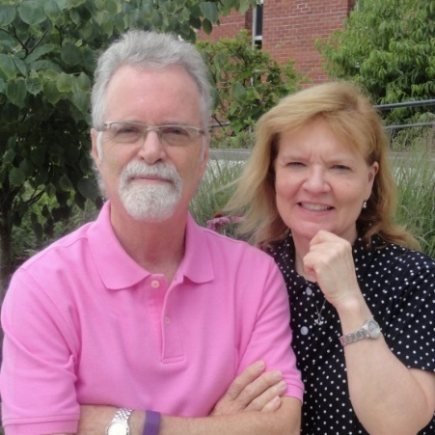  David Marlow, Terri Marlow  Wood County Schools  Spanish Teachers; NBCTs  marlowd@mac.com  marlowt@suddenlink.net | 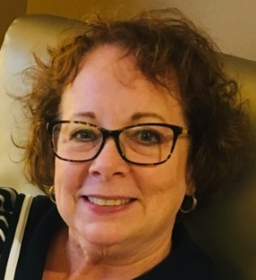  Nancy Ryan, Berkeley County Schools  World Language Coordinator; NBCT  wvsenorita@aol.com

We are former WV language teachers, members of the WV Advocacy for Languages Team, affiliated with the West Virginia Foreign Language Teachers Association (WVFLTA). Our interest in working with language advocacy stems from the fact that we personally have benefitted greatly from learning a second language and know from experience that our communicative ability has given us innumerable experiences that have enriched our life.
And, as former teachers, we want this, and MORE, for the young people of West Virginia. We want them to have the same opportunities to study language as people in any other state or nation. This goal motivates us to find ways to SPEAK UP (!) for language study.
Today more than ever it is critical that US citizens be communicatively and culturally competent with the ability to interact appropriately in our global society. Competence in another language and culture creates opportunities, enhances one’s life, and contributes to career and life success.
The best way to ensure that our young people gain these essential skills
is to include language study as part of a normal school curriculum, giving students the background they need to be successful in the 21st Century.

Languages should be an essential component of a “well rounded education.”

